Final Examination

# **ANSWER**

# **Question 1 (20 marks)**

(a) 60 cm; 4.5 cm **(15 marks)**

(b) 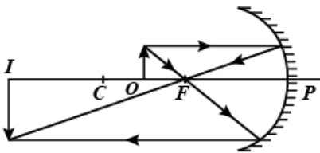 **(5 marks)**

**Question 2 (20 marks)**

(a) ;  **(15 marks)**

(b) Not high precision of the measurement of this electron’s position.

High precision of the velocity’s measurement. **(5 marks)**

**Question 3 (20 marks)**

(a) ; ; ; ;

 **(15 marks)**

(b) : insreases with n (not equidistant) **(5 marks)**

**Question 4 (20 marks)**

;  **(10 marks)**

In the UV region **(10 marks)**

**Question 5 (20 marks)**

(a) 

 **(10 marks)**

(b)  **(10 marks)**

**END OF QUESTIONS**